**Linear Regression**

data **=** pd**.**read_csv('abalone.csv')

data **=** data**.**iloc[:,3:]

data**%matplotlib** inline

**import** pandas **as** pd

**import** numpy **as** np

**import** matplotlib.pyplot **as** plt

**import** seaborn **as** sns

**from** sklearn.preprocessing **import** LabelEncoder, MinMaxScaler

**from** sklearn.model_selection **import** train_test_split

**import** warnings

warnings**.**filterwarnings('ignore')

**Load the dataset**

**Input:**

data **=** pd**.**read_csv('abalone.csv')

data **=** data**.**iloc[:,3:]

data

**Output:**

| **Height** | **Whole weight** | **Shucked weight** | **Viscera weight** | **Shell weight** | **Rings** |
| --- | --- | --- | --- | --- | --- |
| **0** | 0.095 | 0.5140 | 0.2245 | 0.1010 | 0.1500 | 15 |
| **1** | 0.090 | 0.2255 | 0.0995 | 0.0485 | 0.0700 | 7 |
| **2** | 0.135 | 0.6770 | 0.2565 | 0.1415 | 0.2100 | 9 |
| **3** | 0.125 | 0.5160 | 0.2155 | 0.1140 | 0.1550 | 10 |
| **4** | 0.080 | 0.2050 | 0.0895 | 0.0395 | 0.0550 | 7 |
| **...** | ... | ... | ... | ... | ... | ... |
| **4172** | 0.165 | 0.8870 | 0.3700 | 0.2390 | 0.2490 | 11 |
| **4173** | 0.135 | 0.9660 | 0.4390 | 0.2145 | 0.2605 | 10 |
| **4174** | 0.205 | 1.1760 | 0.5255 | 0.2875 | 0.3080 | 9 |
| **4175** | 0.150 | 1.0945 | 0.5310 | 0.2610 | 0.2960 | 10 |
| **4176** | 0.195 | 1.9485 | 0.9455 | 0.3765 | 0.4950 | 12 |

4177 rows × 6 columns

**Visualization process**

**Input:**

*#univariate analysis*

**for** col **in** data**.**columns:

**if** data**.**dtypes[col]**==**'int64' **or** data**.**dtypes[col]**==**'float64':

sns**.**boxplot(x**=**data[col])**.**set(xlabel**=**col)

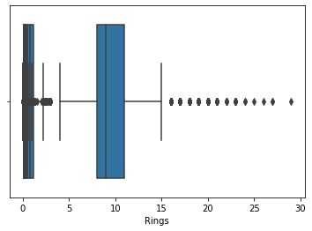

**Input:**

*#Bivariate analysis*

sns**.**FacetGrid(data,hue**=**'Rings',size**=**5)**.**map(plt**.**scatter,"Shell weight","Height")**.**add_legend()

**Output:**

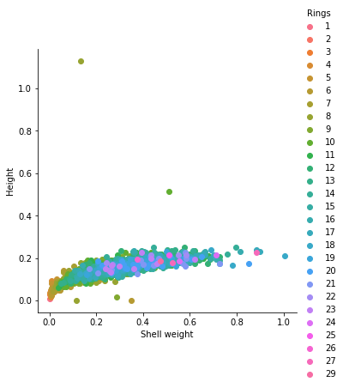

**Input:**

*# 3. Multi-Variate Analysis*

sns**.**pairplot(data,hue**=**'Rings',height**=**4)

**Output:**

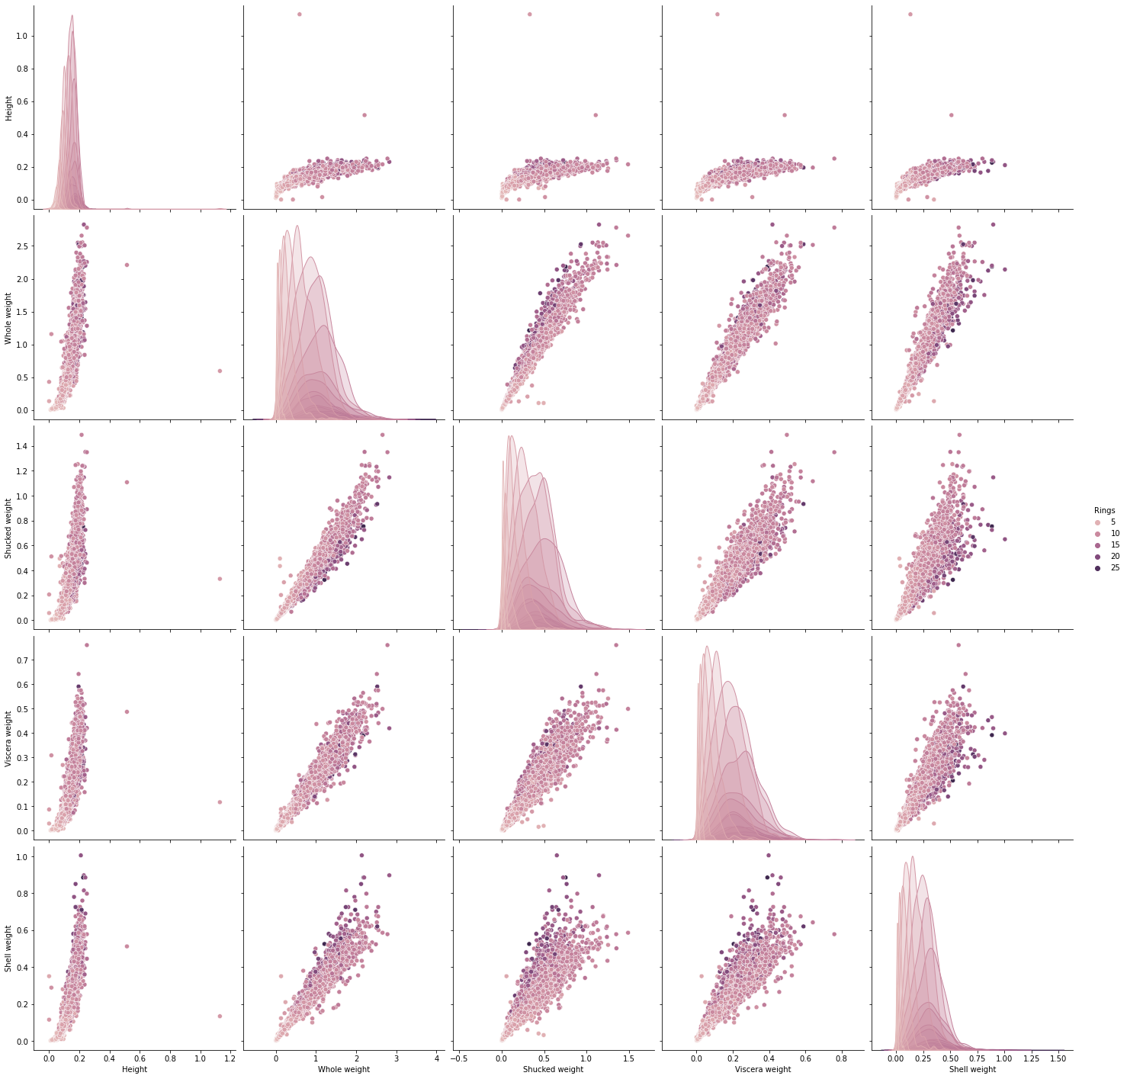

**Descriptive Statistics**

**Input:**

data**.**describe()

**Output:**

|  | **Height** | **Whole weight** | **Shucked weight** | **Viscera weight** | **Shell weight** | **Rings** |
| --- | --- | --- | --- | --- | --- | --- |
| **Countt** | 4177.000000 | 4177.000000 | 4177.000000 | 4177.000000 | 4177.000000 | 4177.000000 |
| **mean** | 0.139516 | 0.828742 | 0.359367 | 0.180594 | 0.238831 | 9.933684 |
| **std** | 0.041827 | 0.490389 | 0.221963 | 0.109614 | 0.139203 | 3.224169 |
| **min** | 0.000000 | 0.002000 | 0.001000 | 0.000500 | 0.001500 | 1.000000 |
| **25%** | 0.115000 | 0.441500 | 0.186000 | 0.093500 | 0.130000 | 8.000000 |
| **50%** | 0.140000 | 0.799500 | 0.336000 | 0.171000 | 0.234000 | 9.000000 |
| **75%** | 0.165000 | 1.153000 | 0.502000 | 0.253000 | 0.329000 | 11.000000 |
| **max** | 1.130000 | 2.825500 | 1.488000 | 0.760000 | 1.005000 | 29.000000 |

**Handle the missing values**

**Input:**

data**.**isnull()**.**sum()

**Output:**

Height 0

Height 0

Whole weight 0

Shucked weight 0

Viscera weight 0

Shell weight 0

Rings 0

dtype: int64

**Find and Replace the outliers**

credit **=** data**.**loc[data['Height']**<**400, 'Height']**.**median()

prod **=** data**.**loc[data['Rings']**>=**3.5, 'Rings']**.**median()

data**.**loc[data**.**Height**<**400, 'Height']**=**np**.**nan

data**.**fillna(credit,inplace**=True**)

data**.**loc[data**.**Rings**>**3.5, 'Rings']**=**np**.**nan

data**.**fillna(prod,inplace**=True**)

**Perform encoding for Categorical Columns**

data['Whole weight'] **=** label**.**fit_transform(data['Whole weight'])

data['Shucked weight'] **=** label**.**fit_transform(data['Shucked weight'])

**Dependent and Independent variables**

dep **=** data**.**iloc[:,**-**1:]

indep **=** data**.**iloc[:,:**-**1]

**Scale the independent variables**

indep_var **=** MinMaxScaler()

show_indep **=** indep_var**.**fit_transform(indep)

**Splitting Train and Test Data**

xtrain,xtest,ytrain,ytest **=** train_test_split(show_indep, dep, test_size**=**0.3)

print(xtrain,xtest,ytrain,ytest)

[[0. 0.91680395 0.86856011 0.47399605 0.49775785]

[0. 0.36985173 0.24438573 0.16063199 0.25759841]

[0. 0.06342669 0.06340819 0.03620803 0.04235177]

...

[0. 0.1630972 0.15323646 0.09282423 0.09367215]

[0. 0.1985173 0.17701453 0.10533246 0.11559542]

[0. 0.20551895 0.18295905 0.0757077 0.12306926]] [[0. 0.27182867 0.22457067 0.0921659 0.16691579]

[0. 0.24052718 0.23117569 0.15273206 0.11559542]

[0. 0.28459638 0.28929987 0.13824885 0.12755356]

...

[0. 0.17792422 0.167107 0.06649111 0.10413553]

[0. 0.08401977 0.07529723 0.03291639 0.05829596]

[0. 0.12067545 0.11889036 0.05069124 0.07573493]] Rings

1981 10.0

2187 10.0

3632 10.0

1602 10.0

1930 10.0

... ...

661 10.0

2860 10.0

1554 10.0

560 10.0

2638 10.0

[2923 rows x 1 columns] Rings

613 10.0

1453 10.0

938 10.0

1131 10.0

2628 10.0

... ...

306 3.0

2367 10.0

2378 10.0

319 10.0

3532 10.0

[1254 rows x 1 columns]

*#visualize the first five row*

data**.**head()

|  | **Height** | **Whole weight** | **Shucked weight** | **Viscera weight** | **Shell weight** | **Rings** |
| --- | --- | --- | --- | --- | --- | --- |
| **0** | 0.14 | 715 | 417 | 0.1010 | 0.150 | 10.0 |
| **1** | 0.14 | 285 | 178 | 0.0485 | 0.070 | 10.0 |
| **2** | 0.14 | 962 | 480 | 0.1415 | 0.210 | 10.0 |
| **3** | 0.14 | 718 | 400 | 0.1140 | 0.155 | 10.0 |
| **4** | 0.14 | 253 | 159 | 0.0395 | 0.055 | 10.0 |

data['Height']**.**unique()

array([0.14])

**from** sklearn.linear_model **import** LinearRegression

model **=** LinearRegression()

**Build a model**

**import** statsmodels.formula.api **as** smf

model**=**smf**.**ols("Height~Rings",data**=**data)**.**fit()

**Test model**

model**.**params

**Output:**

Intercept 1.400000e-01

Rings 7.329207e-17

dtype: float64

model**.**rsquared , model**.**rsquared_adj

**Output:**

(-1151.283935839119, -1151.5599319914159)